
Payment Acknowledgment Letter

Acceptance Date: 20/07/2022

Subject: Decision Letter to Authors Regarding Payment
Title:
A MODEL TO ENHANCE SECURITY IN SOFTWARE DEFINED
NETWORKING (SDN)
Dear Authors: Mr. SHAIK MOHAMMED SHAFIULLA , ASSISTANT PROFESSOR, SCIENT INSTITUTE OF TECHNOLOGY
After peer review process, your article has been provisionally accepted for rapid publication in Journal Of Engineering Science in Vol 13 Issue 07,2022.We received a payment of Rs : 5000/- on 15th June 2022 towards publication fees. All submitted manuscripts are subject to peer- review by the leading specialists for the respective topic.

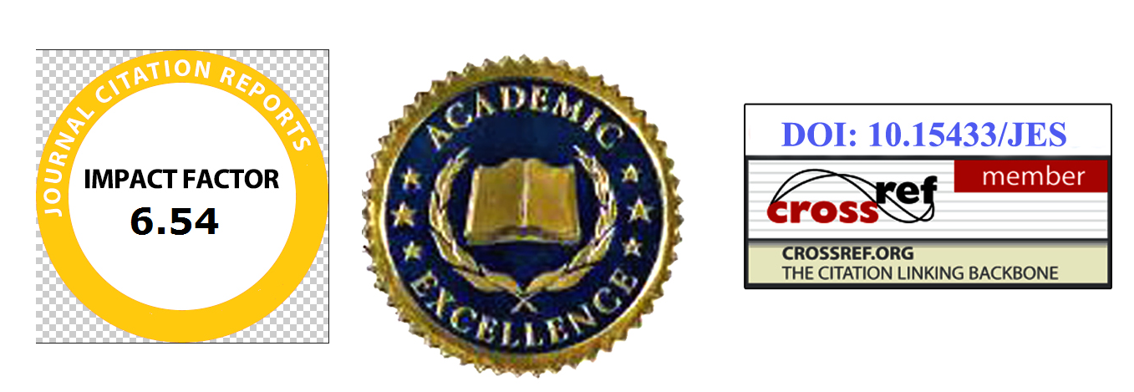
Regards Journal Of Engineering Science
Editorial Manager editor@jesugcpublication.com
https://jesugcpublication.com/

