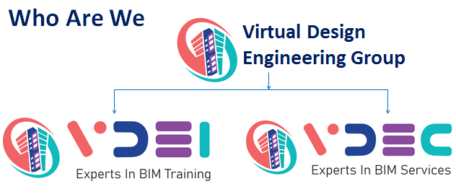

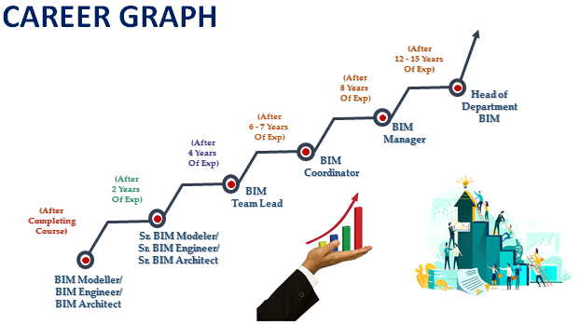

“Transforming People….. Shaping Minds”
PROFESSIONAL
BIM Certification in ARCHITECTURE
Course Duration – 2 Months– 120 Hrs

- Job Opportunities: While full course of BIM helps open door of BIM Engineer, BIM Expert
- Eligibility: BE / Diploma in Civil, Architects.
- Duration: Daily 4 Hours for 2 months.
- Online Training: No/Only in case of Lock down.
- Placement Support: No
- Software Training Revit MEP, Navisworks,
- Method of Training Classroom training, live case studies, assignments, demonstration, practice & Live Project
Work.
- Language English/ Hindi
- Certification Yes, by VDEI You need to attend all sessions, complete all assignments, appear for an
external viva and pay all fees to be eligible for the certificate.

BENEFITS & COURSE OUTCOMES
BIM MEP Modeling and Coordination Course is the most practical and innovative academic program designed to meet the requirements of the AEC industry, where we train students every year globally. This program is ideal for the professionals and students from Mechanical & Electrical Engineering background.

On successful completion of the program, participants will be exposed to many international projects and will have the necessary skill and competencies to be become “job-ready” for the industry. Number of Job vacancies for BIM professionals in the market is scaling up in a tremendous rate, as the requirement of BIM Is mandatory in all main construction projects happening across the globe.

- Become a BIM Engineer specialized in all MEPF disciplines working with open BIM and interoperability.
- Exposure to the international project by working on various projects from day one of the course.
- Discover all the latest BIM software and the appropriate methodologies to use it over the diﬀerent project life cycles.
- Experience the complete project workﬂow during the Final Project Internship (Includes Personalized Mentoring).

INTRODUCTION TO BIM (Building Information Modeling) 3 Hours

Exposure to BIM authoring tools where a student will get familiar with the BIM tools and processes.

- Autocad 3 Hours
- Projection-Isometric-Sectional view
- Line, save as and save, template, unit
- Point, circle, arc, ellipse, regen, erase, zoom & pan
- Polyline, revision cloud, pedit, polygon, rectangle, explode, move, rotate, scale, mirror
- Copy, offset, array, stretch, break, trim, extend, fillet, chamfer
- Block, annotation scale,, divide, measure, layer, toolbar, area, match property
- Attaching Image, Paste, Hatch, line typ
- Text style, Mtext, Find and replace, Dimension style
- Attribute, spell check, paper size, layout creation, layout setup, viewport creation, PSLTSCALE
- Filter, Xref, UCS, view, CTB, Export
1st Assessment Test

- Revit Architecture 3 Hours
Basic Fundamentals of Revit-
- Understanding on BIM
- Understanding 3D elements
- Revit concept
- Explain about the difference between CAD – 3D modelling
- Files open , close , saving the file process
- Explanation about tools and their uses in revit
- Explanation about Design options
- Explanation about Phases
- Setting up levels and grids
2nd Assessment Test

- Modelling-
- Placing and sketching the elements
- Editing properties of modify tools
- Creating Building exterior and interior walls
- Placing the doors and windows
- Crating Curtain walls, curtain grids and Mullions
- Creating and sketching floor as required with thickness and slopes.
- Creating roof and roof elements with required properties
- Create and Place the ceiling with customized properties
- Placing Furniture and Plumbing Equipment as per building requirement
- Wall Openings and floor openings as per requirement of building
3rd Assessment Test

- Family Creation-
- Creating the New families
- Modify the default families
- Understanding the loadable families
- Creating extrusion, sweeps and revolve, bends
- Creating Void forms
- Creating parametric families
- Created hosted families
- Creating nested families
- Creating detail item families for documentation purpose
- Creating shared and project parameters
- Creating parametric with formulas
- Creating Families as per required levels like (LOD 100-500)
- Creating Adoptive Families
- Creating Annotation Families
- Creating Annotation Tagging Families
- Creating materials with properties and color coding’s
4th Assessment Test

- Annotation for Documentation
- Using text notes
- Working with Tagging families
- Creating Different types of hatches as required for project
- Creating the Rooms for Room data
- Creating keynotes for elements
- Create keynote legend
- Create Legends and Drafting Views
- Create color fill legends
5th Assessment Test

- Scheduling
- Creating schedules with required files of parameters
- Creating Project and shared Parameters
- Modify the Schedules by filters, sorting and grouping
- To modify Schedule formatting, Headers and footers
- Placing schedules on sheets.
- Exporting Schedule in Excel format
- Creating Views list and sheet list
- Creating Material Take-off Schedules
- By using Schedules we can extract BOQ and Cobie related data
- Extracting Room data
6th Assessment Test

- Project Template Creating
- Creating Customized Project browser for views and sheets
- Creating Project Template for Metric and imperial
- Modifying the Project Properties
- Creating View templates
- Create Families for Specified Categories
- Setting Starting View
7th Assessment Test

- Collaborate models
- Creating and working on local server and cloud model
- Controlling the Coordinates in Linked Revit Models
- Monitoring and Coordinating Changes within a Single Project
- By Using Copy Monitor in a Single Project
- Transfer Project Properties and parameters
- Performing a Coordination Review with Linked Models
- Create and Understanding about Worksets
- Understanding Work-sharing concept
- Creating Local file and how to work on that
- Create central file and how to do the work and syncing process
- Coordination review with linked models
- Checking clash interference with Revit
- Working knowledge of BIM 360 and other Cloud platforms
8th Assessment Test

- Parameters Creating
- Cobie Data Extraction
- Massing & Siting
- Creating In-Place Mass Families as per required Category
- Creating In-Place Family by using Solid Extrution, Solid blended,Solid revolve forms
- Creating In place Mass void forms
- Creating Topo surface by using elevation points
- Creating topo surface by using CAD Elevation points
- Creating Building pad and graded region
- Creating parking components and Property lines
- Creating point base points and Survey base point.
9th Assessment Test

- Basic Dynamo
- Rendering and Walkthrough Concept
- Introduction and explanation about Rendering Concept
- Creating Required views for render
- Modify the render settings
- Using lightings and sun settings
- Modify and set up the render back ground color
- Creating or modify the materials as per required colors
- Create render by our local server or Render in cloud
- Create Walkthrough Path and edit the path
- Editing Frames in Walkthrough
- Exporting Walkthrough by .mpeg or .mp4 or .Avi formats.
- Uses of Revit-add ins
- By using of Revit addins we can simplify the work procedure
- By using revit addins we can create the parameter data

10th Assessment Test

- BIM using Navisworks 3 Hours
- Exporting Revit
- Appending and merging files
- The Navisworks interface
- Overriding & finding items
- Creating Sets
- Creating, Importing construction schedules
- Time-liner
- Using clash detective
- Batch, Rules, Select, Results, Reports etc
11th Assessment Test

- Revit Structure
- Basic Fundamentals of Revit-
- Understanding on BIM
- Understanding 3D elements
- Revit concept
- Explain about the difference between CAD – 3D modelling
- Files open , close , saving the file process
- Explanation about tools and their uses in revit
- Explanation about Design options
- Explanation about Phases
- Setting up levels and grids
12TH Assessment Test

- Modelling
- Explanation about basic Structure construction procedure
- Understanding structural elements
- Creating structural columns, Beams, Foundations
- Creating slabs , slab edges
- Creating Structural steel columns, Beams, and trusses
- Explanation about the beam and column properties.
- Modifying sizes of beams and columns
- Creating Structural walls, braces, Structural framings
- Creation of 3D rebar modelling.
- Creating Structural connections
- Placing Area and Path Reinforcement
- Creating Structural Stair Components
- Creating Multi-Story Stairs and Shafts
13TH Assessment Test

- Scan to BIM ARCHITECTURE & STRUCTURE 3 Hours
- 3d, 2d drawing creation
- CORPORATE COMMUNICATION 3 Hours
History of global communication, Verbal, Nonverbal, Visual, Listening, Email writing, gesture etc.
- REALTIME PROJECT EXPERINCE/ INTERNSHIP FOR A MONTH
- A live project exposure is oﬀered in this module for our students where they work with our BIM Team to learn various aspects of BIM process, so that they will be ready to work on International projects.
Key Contents:
  - Project Template Creation
  - Understanding of Project Documents
  - Project Coordination

Final Assessment Test

